**Lab 0: ADS Familiarization**

**Objective:**

The purpose of this laboratory familiarize the student with the ADS (Advanced Design System) design software through common situations that will be encountered in the EEL5439C lab.

Topics Covered

1. Creating a New Project
2. LineCalc
3. Microstrip Lines
4. RLC Circuits
5. Import Transistor Simulation Files
6. Import S-parameter data files
7. Creating a New Project

To begin using ADS, we must first have a project to work in. From the main menu, choose File | New | Workspace.

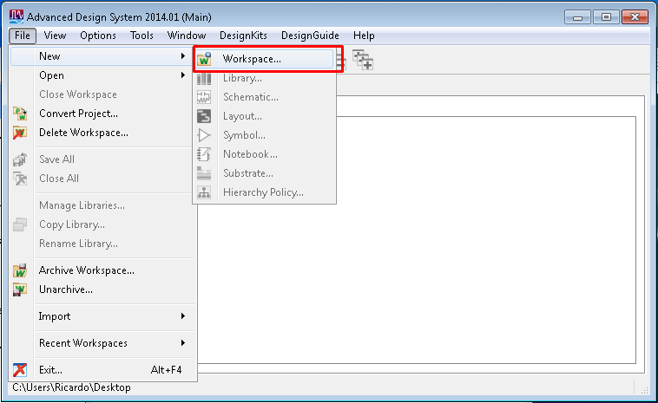

Give your workspace a meaningful name and finish the wizard.

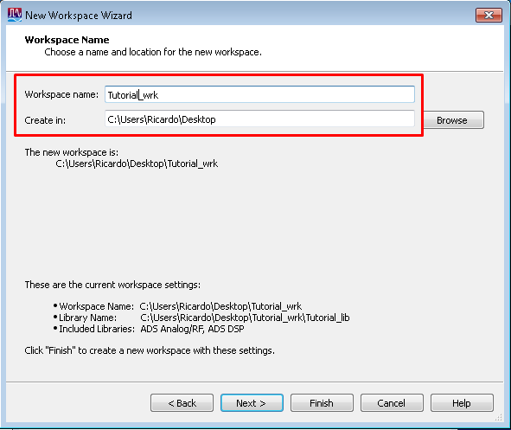

To add a new schematic to your project, right click on your project and choose New Schematic.

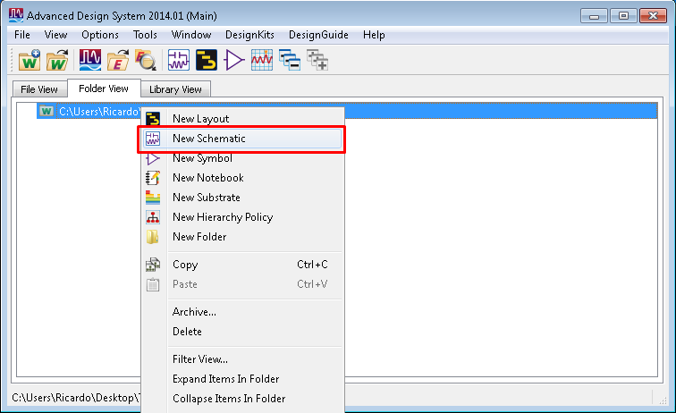

Name the schematic something meaningful. For this example, we can simply call it “tutorial_schematic”. A wizard will open when the schematic opens, close out of this as it will not be necessary.

1. LineCalc

LineCalc is a utility that can be used to calculate physical dimensions for microstrip circuits. To start LineCalc, from the schematic screen select Tools | LineCalc | Start LineCalc as shown below.

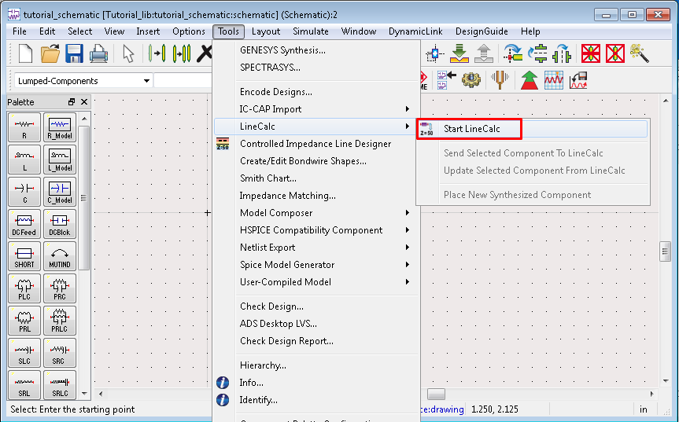

The main screen of LineCalc is shown below.

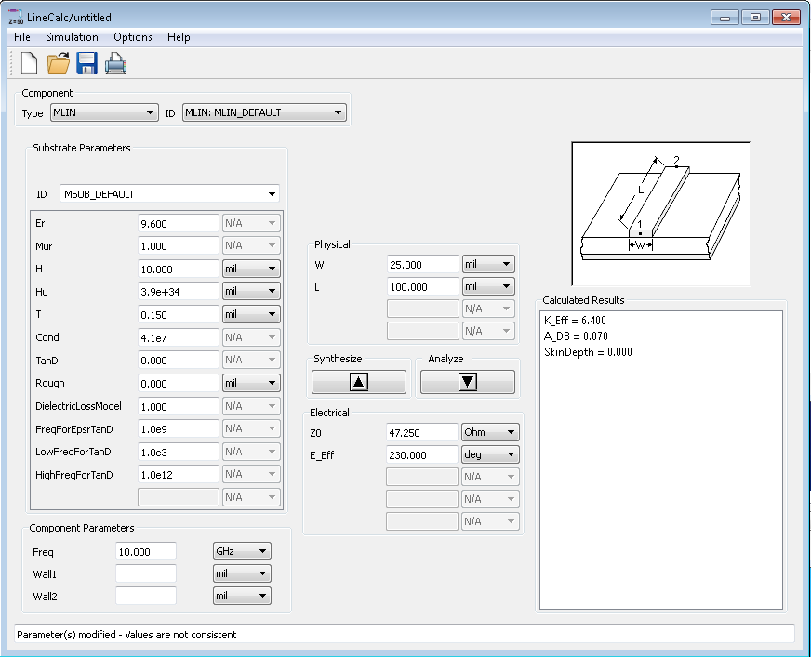

An explanation of the parameters is as follows:

1. Er – Effective relative dielectric constant.
2. Mur – Permittivity (1.0).
3. H – Thickness of the substrate, usually specified in mil (mil is not mm).
4. T – Thickness of the copper line, usually 16um or 32um.
5. TanD – Loss tangent.

In this course, we will use the Rogers 4003C substrate. A google search for the datasheet of this substrate returns all of the relevant design parameters.

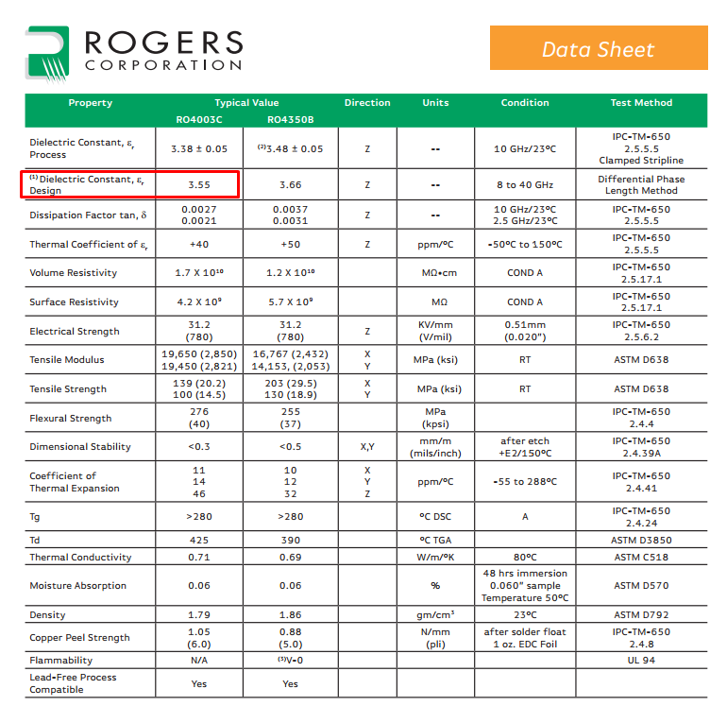

Of particular note for our calculations, we want to use the design dielectric constant when making calculations. For this example, we want to calculate the microstrip line width at 1 GHz for a 50 ohm characteristic impedance line. Assume a substrate thickness of 32 mil. Your LineCalc screen should resemble the below image when you are finished inputting the substrate characteristics. You should also change your physical dimensions to mm before calculating. To begin the calculation, press synthesize and you will receive the physical dimensions. To go the other way and calculate the characteristic impedance based upon a line width, click analyze. E_eff is the electrical length of the line and from the results we can see that an electrical length of 90 degrees (a quarter wavelength) comes out to 45 mm.

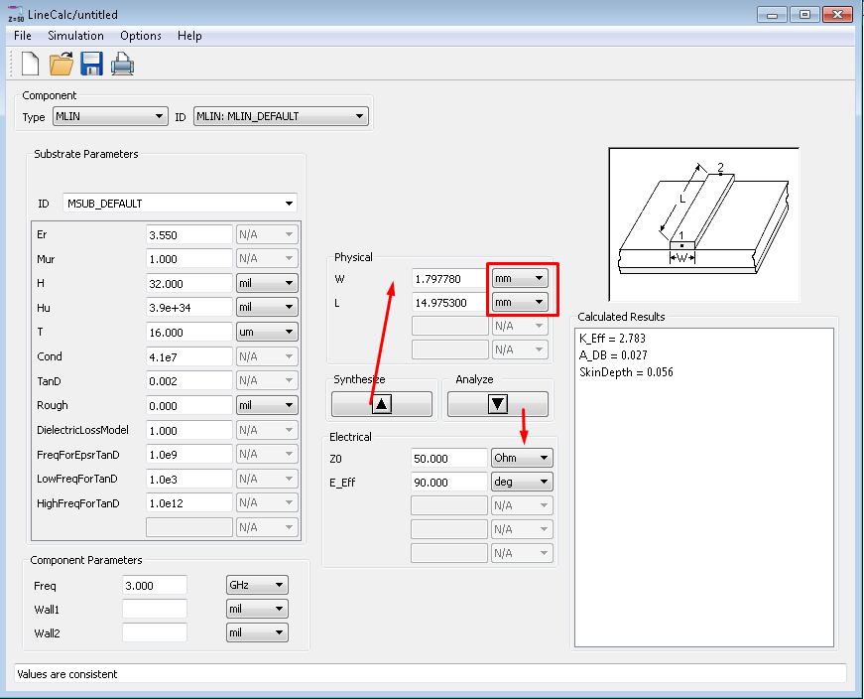

1. Microstrip Lines

In this example, we will use a textbook example of transmission line matching from Dr. Gong’s lecture notes in Lecture 6.

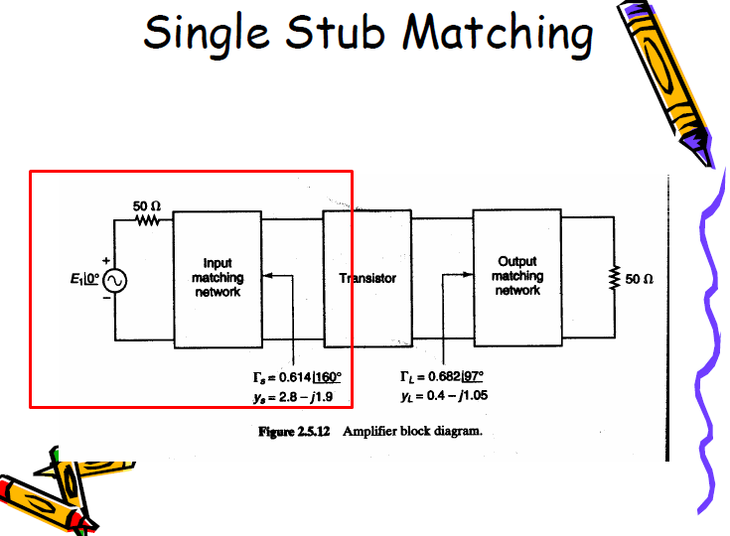

For this demonstration, we will only focus on the input matching network for the transistor. To begin, we need to add our S-parameter components as shown below.

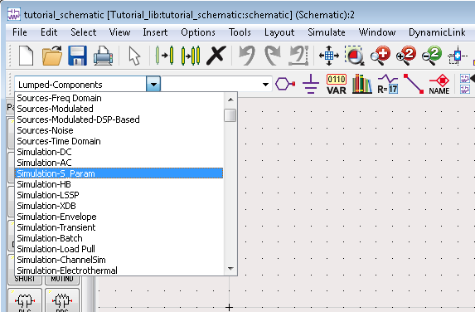

We will need a frequency sweep and two ports to perform this simulation.

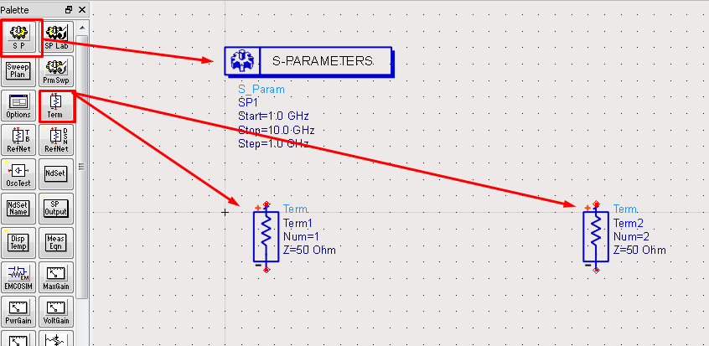

To change the parameters of the frequency sweep, double click on the S-Parameters box and edit the dimensions of the sweep as shown below. You may change either the number of points or the step size and the other box will automatically update.

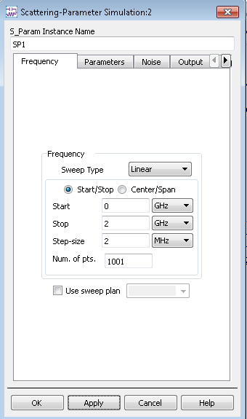

Next, we will add our microstrip components to the schematic. Find the microstrip line component menu as shown below.

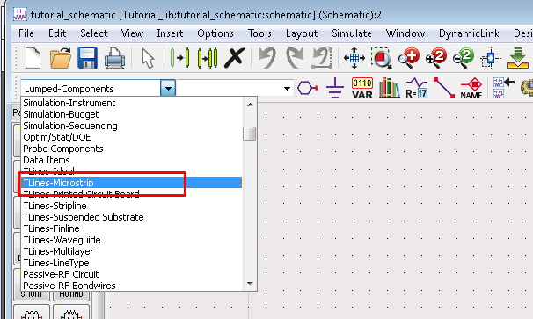

We will need several items to complete the matching network. Find the buttons for the substrate parameters, microstrip line, open circuit stub, microstrip tee, and ground and add them to your schematic as shown in the image below.

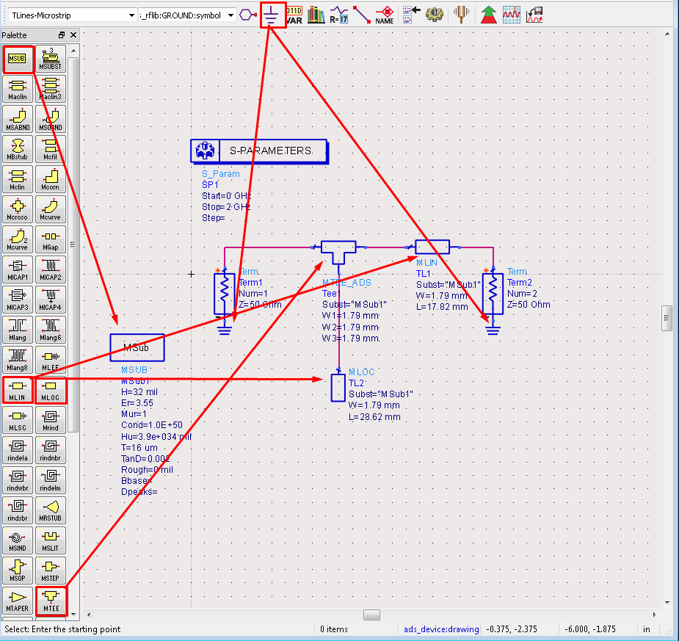

You will notice that I have already added the lengths and widths to the microstrip components. From the previous exercise with LineCalc, we found that a 50 ohm line is 1.79 mm wide. To determine the lengths of the microstrip lines, we refer to the problem solution.

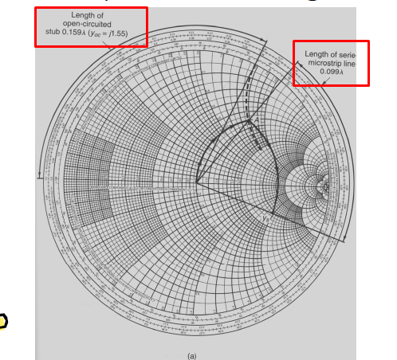

We see that our series microstrip line must have a length of 0.099λ and our stub must have a length of 0.159λ. Returning to LineCalc, we can calculate a 0.099λ in terms of electrical degrees as 0.099λ * 360º = 35.64º.

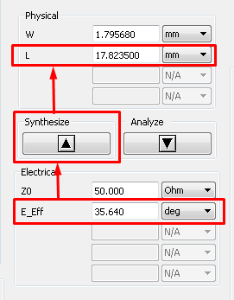

Performing the same calculation for the stub, we find that 0.159λ * 360º = 57.24º = 28.62 mm.

Next, we must update our substrate information so that ADS knows how to perform the calculations based on length and width of our transmission lines. Double-click the MSub box and update the substrate information as we did with LineCalc and as shown below.

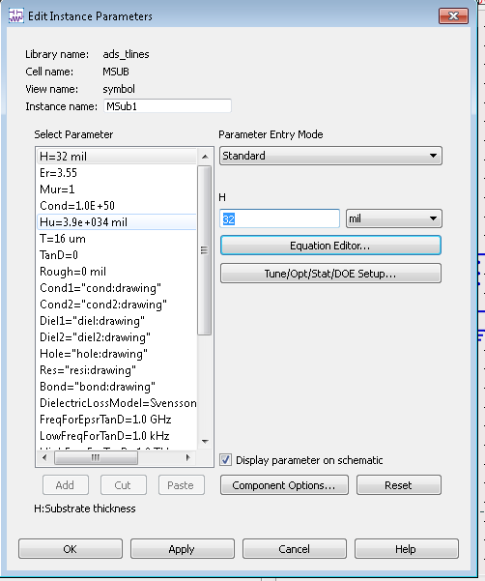

Now that all of our schematic information is complete, we can simulate our circuit. To simulate, click the image of the gear in the top bar.

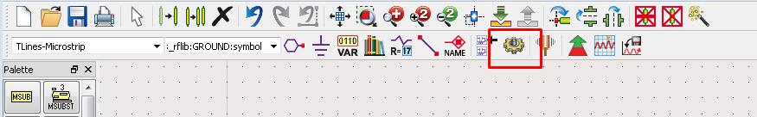

When the simulation is complete, a new blank window will open. To add the Smith Chart, click the image of the Smith Chart as shown below.

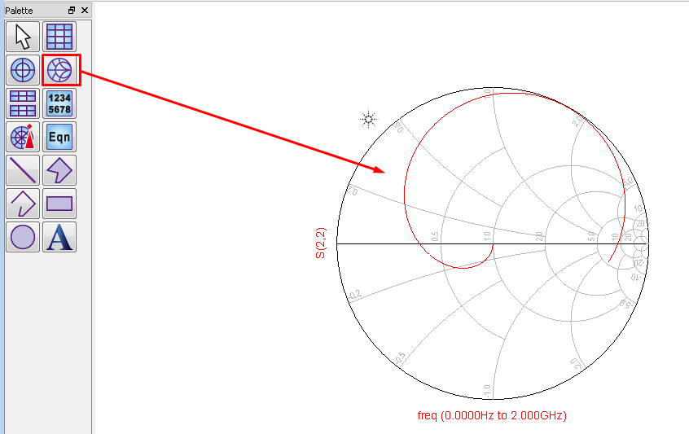

For this circuit, we are interested in looking at S21. Select this from the left menu and press add to add this measurement to our Smith Chart.

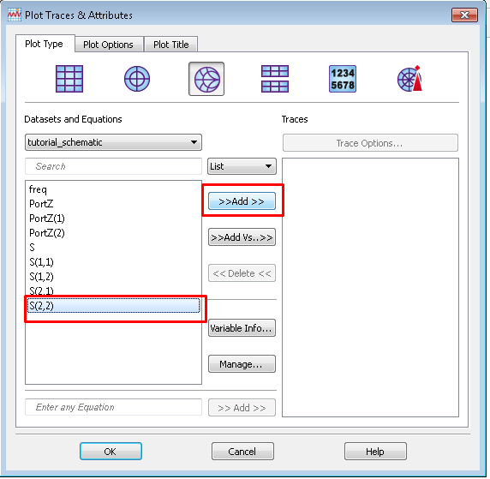

To view the measurement at a specific frequency, click the marker button and then click somewhere on the trace inside the Smith Chart to add the marker to an arbitrary point.

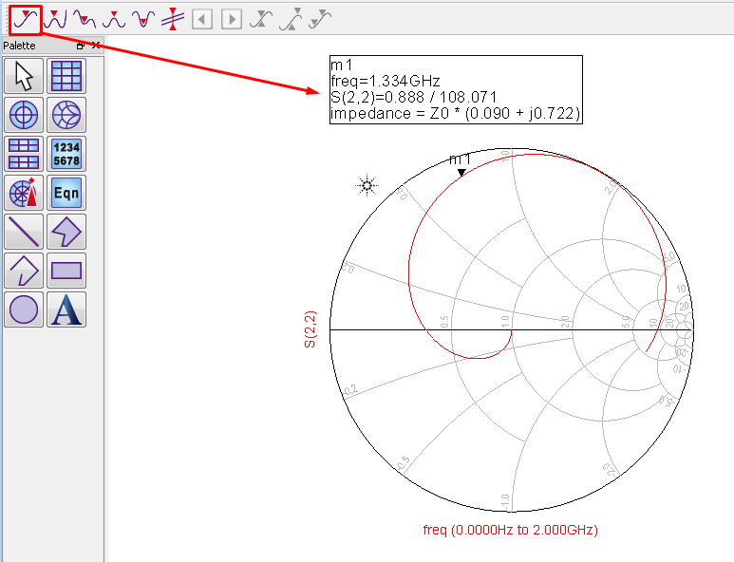

To view the impedance, double click click the marker box and change the Smith Chart value type from Impedance to Admittance as shown below.

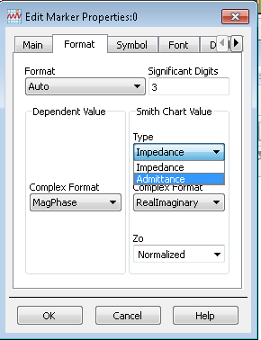

Now that our marker is in admittance mode, click on the frequency (or drag the cursor on the trace) and change it to 1 GHz.

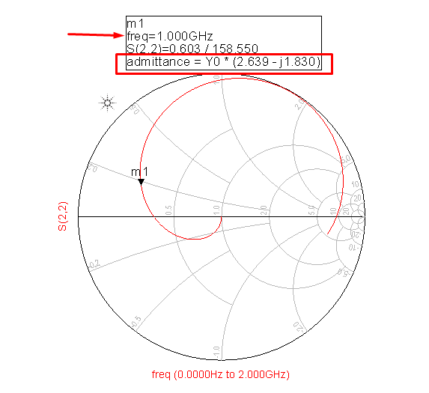

We see that our admittance at 1GHz is y = 2.639 – j1.830 and the solution to our lecture problem is 2.8 – j1.9. While not exact, these values are close and may be brought closer by tuning the microstrip lengths. There are a number of reasons they may differ including losses and assumed ideal values.

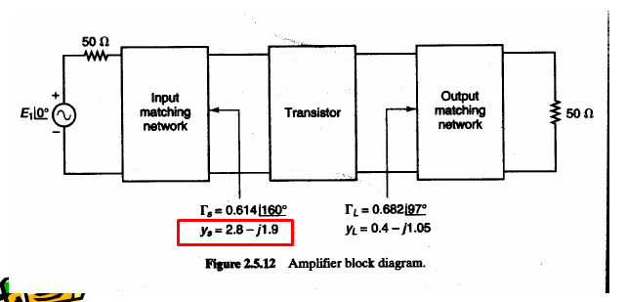

1. RLC Circuits

To demonstrate RLC circuit design in ADS, we will again use an example from the EEL5439 lecture notes. In Lecture 5, page 13 an example of an LC matching network is given. To begin, create a new schematic as shown above and add the S-parameter components as demonstrated. For RLC circuits, we will not need the MSUB component as there are no microstrip lines.

For this example, our second port is defined as a resistor in series with an inductor as shown below.

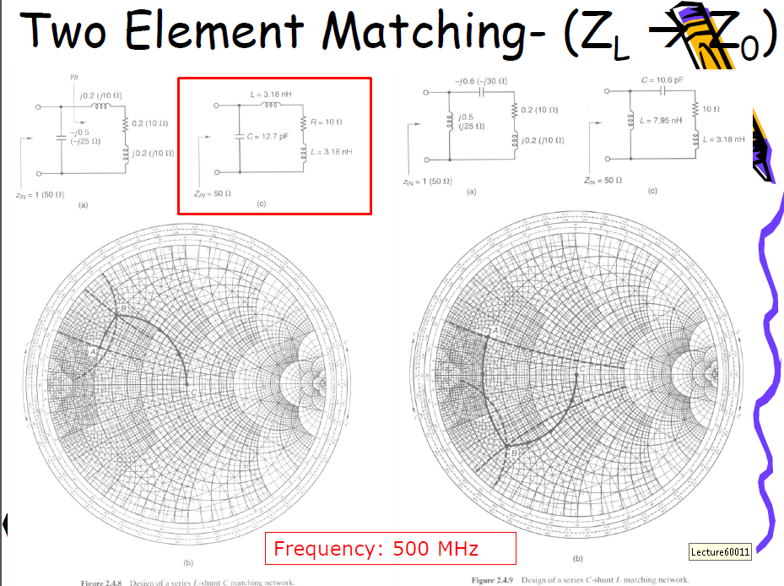

Using the “Lumped-Components” dropdown, build the circuit as shown below. Note that we only have one S-parameter port as our second port is given as the RL combination.

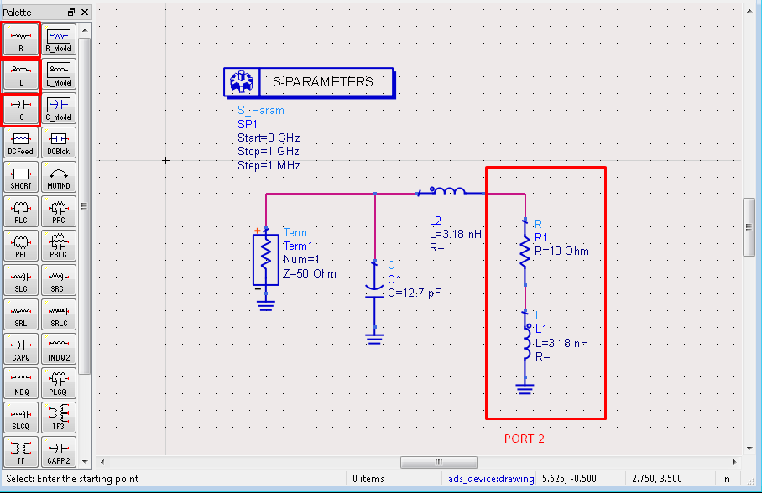

As demonstrated before, change the frequency sweep from 0 GHz to 1 GHz with a step count of 1001. When all values have been edited as shown below, simulate the circuit and add a Smith Chart. Add a marker to the Smith Chart as demonstrated previously and change the frequency to 500 MHz as called for in the problem text. As we can see from the Smith Chart below, we have a perfect match at 500 MHz.

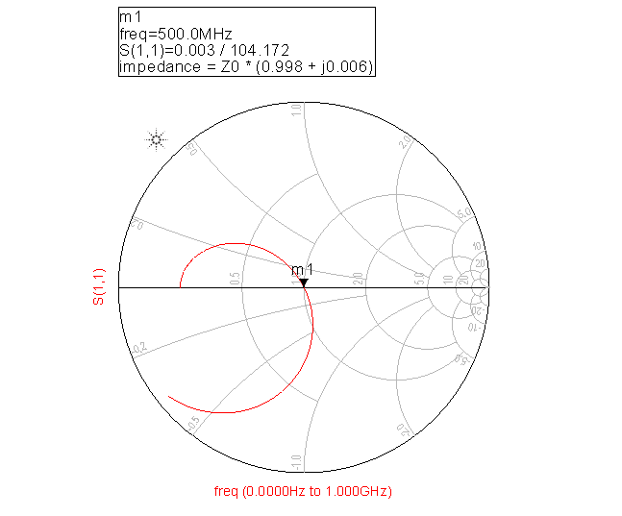

1. Import Transistor Simulation Data Files

In this course, we will be using the Avago AT-41486 BJT. Perform a google search for this device and you should find the relevant page on Avago’s website. To download the ADS simulation data for this transistor, download the .ZAP file from the website as shown below.

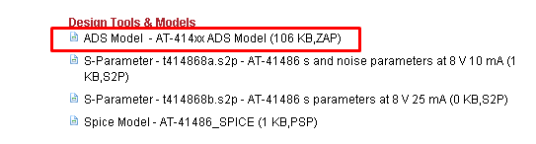

To unpack this file, click File | Unarchive from the main ADS menu.

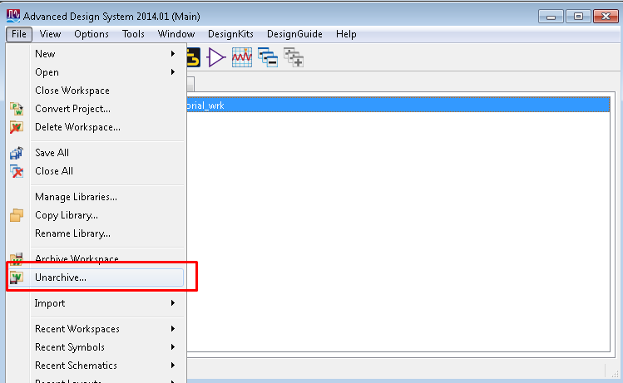

Find the file and work through the wizard, saving the file in a location of your choice. The default name, “AT414xx_wrk” is acceptable.

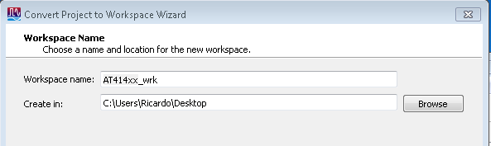

At this point you may hit Finish. When the file has unpacked, ADS will ask you if you want to open the new ADS workspace. Choose no. Open your tutorial workspace again if it was closed and navigate to the Library View menu. Right click in your library view tab and click Manage Libraries to add your new transistor library to your workspace.

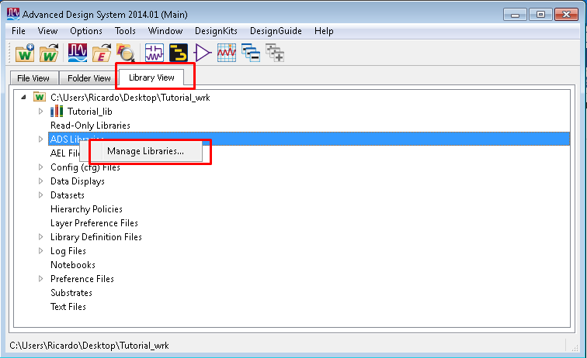

Click “Add Library Definition File…” to add the transistor to your workspace. Navigate to your “AT414xx_wrk” folder and open the lib.defs file.

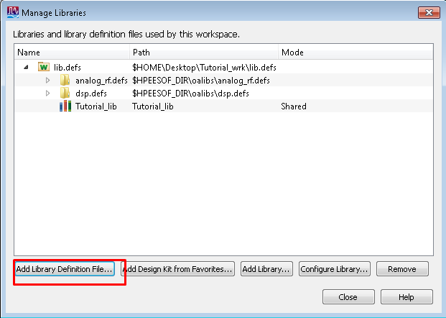

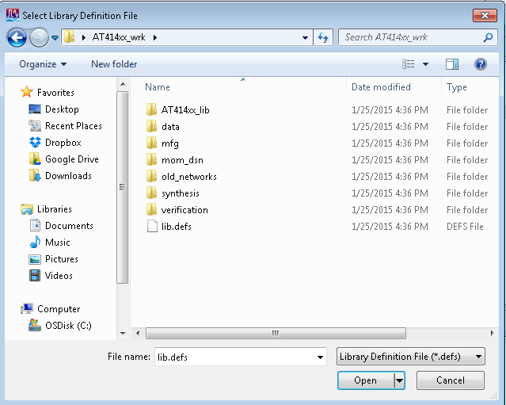

You should now see the AT414 library added to your manage libraries screen as shown below.

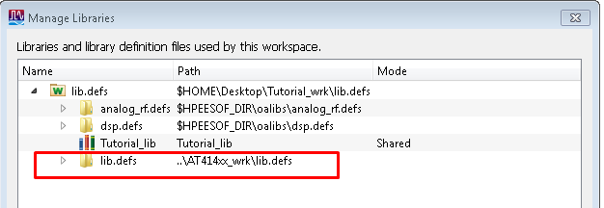

Navigate back to your folder view within ADS and you should see a number of transistor folders added to your workspace. The one will use for this course is the AT41486.

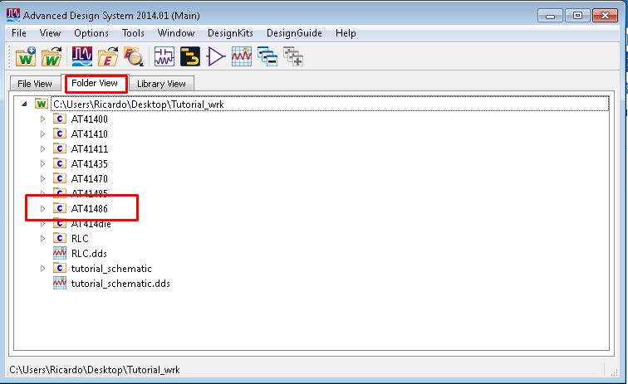

Create a new schematic as demonstrated above. To add the transistor to your project, have both the schematic and main ADS windows on screen simultaneously. Click the arrow next to AT41486 and drag the “Symbol” onto your schematic as shown below.

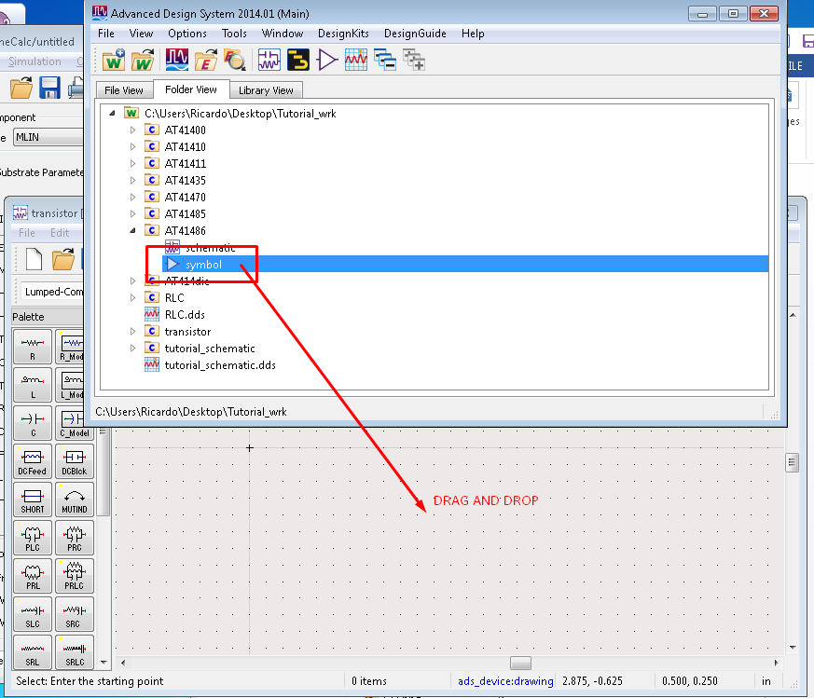

The resulting symbol in your project may not be what you expect as a BJT and we can edit the symbol to the traditional BJT symbol we are used to. To edit the symbol, return to the main ADS menu and double click “symbol” under the AT41486 library.

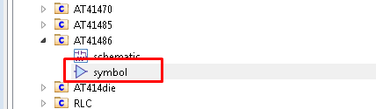

The resulting screen should resemble what you see below. Delete everything from this screen.

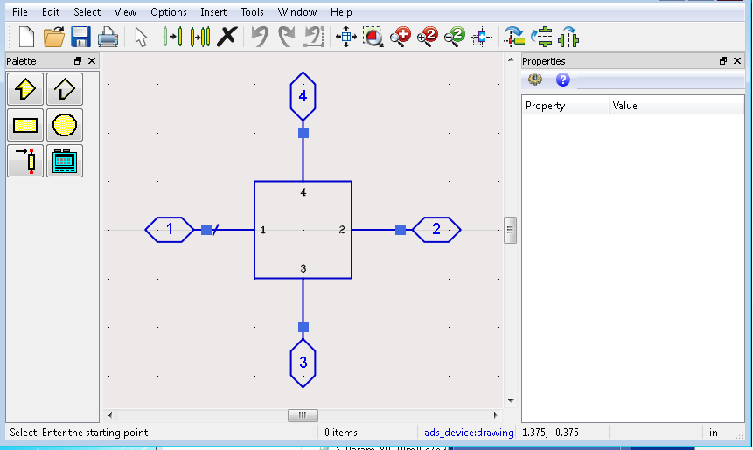

To insert a new symbol, choose Insert | Generate Symbol from the symbol editor screen.

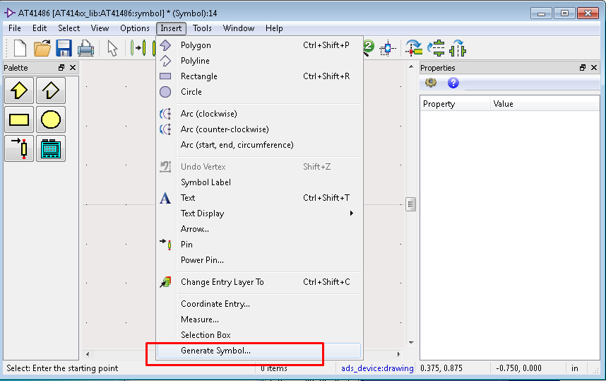

From the Copy/Modify menu, select Devices-BJT and BJTNPN as shown below.

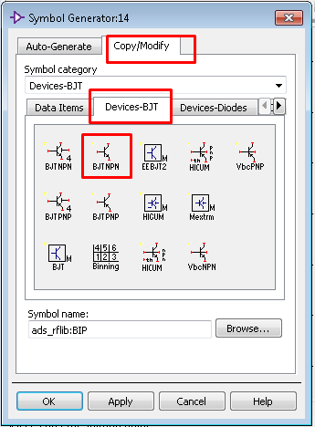

To determine the correct pin mappings, open the AT41486 schematic from the main ADS menu and inspect the pin numbers.

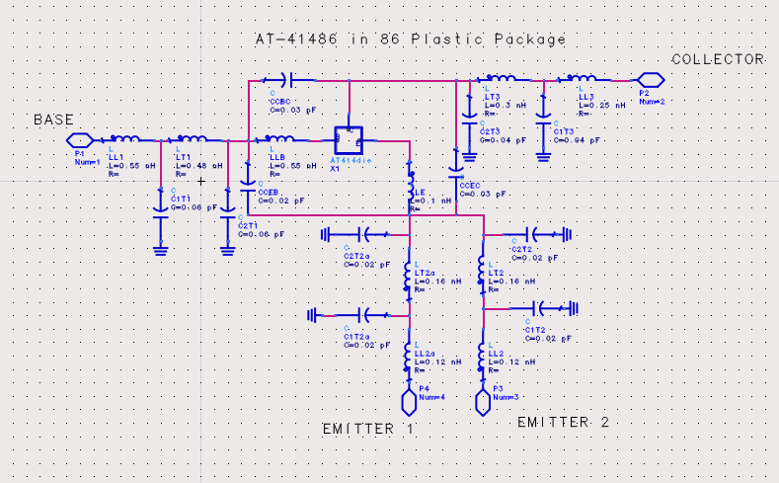

From this schematic, we see that base should be pin 1, emitter should be pin 3 and collector should be pin 2.

Update your schematic according to your layout.

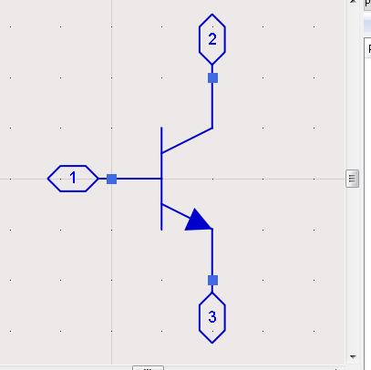

Save changes to your symbol and return to your original schematic. You should now find that your transistor symbol has changed to the traditional BJT symbol.

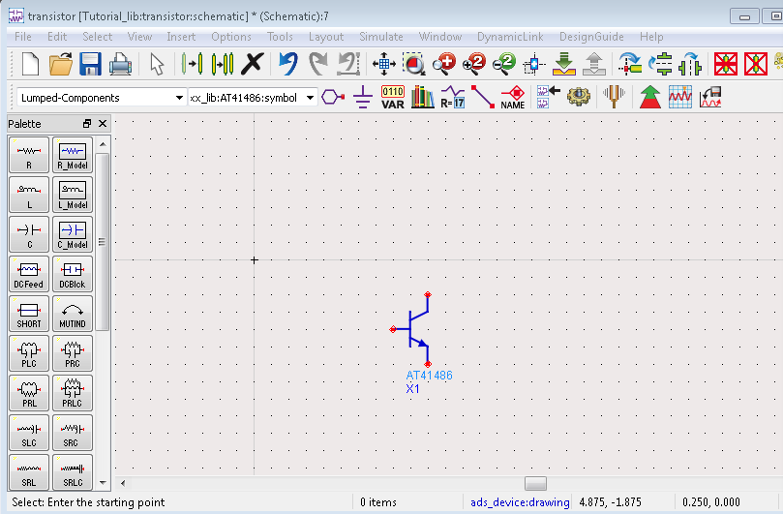

For DC circuits, you can find your power supply under the “Source-time Domain” and resistors where they were found in the RLC section. To perform DC simulations (to measure current and voltage), you can find the DC simulation component under “Simulation-DC” and the current/voltage probes under “Probe Components”.

1. Import S-Parameter Data Files

For each lab, you will receive S-parameter files from the network analyzer that you will need to analyze for your lab reports. One port S-parameter files have the extension .s1p and two port measurements will have the extension .s2p. To open these files in ADS, you will need to add a S-parameter simulation component as demonstrated above, the relevant number of ports, and you will need to import your data files. To open S-parameter data in ADS, navigate to the “Data Items” menu as shown below.

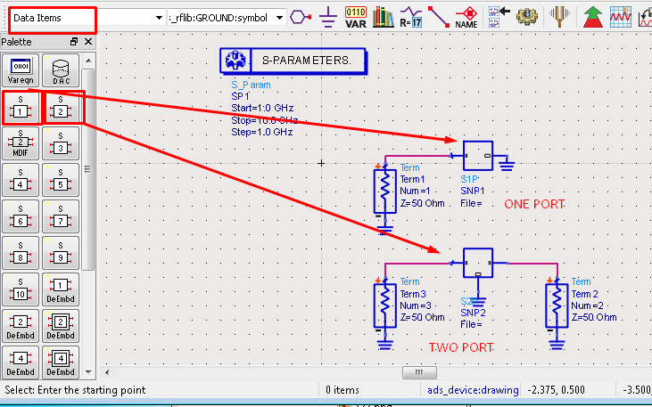

One port measurements will only require one terminal and two port files will require two. To add your data files, click on the data import component and navigate to your file. Ensure your S-parameter frequency range will cover your frequency range in your measurement file with a sufficient number of data points. Simulate the circuit as usual and you may add S-parameter xy plots, Smith Charts, or any data display tool of your choice within the simulation results window.